**Foundation of GIS**

**Project on**

**“Finding Suitable Land for Farming in Cambridge”**

**Prepared by Under the guidance Pankti Patel Prof. Connor Reed**

**Introduction**

As a newly formed Urban Agriculture Task Force, the Community Development and Public Health Departments worked in collaboration with the Food and Fitness Policy Council to discuss issues related to urban agriculture development in Cambridge. This program aims to find ways to contribute to increasing the quality and access to safe and nutritious foods and to help them improve access to and availability of healthy and affordable food and support sustainable, economic and educational opportunities involving urban agriculture and innovative urban farming technologies within the City.

The Task Force has been involved in a process of proposing a comprehensive policy on urban agriculture that will consider a wide range of urban agricultural activities. The task force has been tasked to establish a policy framework that involves specific zoning to allow promoting and restricting activities for agricultural operations, as well as public health regulations.

The city of Cambridge is committed to maintain a healthy urban forest. This project is to increase farming in Massachusetts. Much of the land in the city of Cambridge has been developed, mostly for industrial use, However, growing population of farmers has created demand for agricultural uses. The city’s extension education program and the improvement of planting and management practices have earned them a growth award for the past three years. This project is to find prospective areas for urban farming.

**DataSets**

This dataset is a Vector data.

**There are total four files**

**Data Attributes**

**Cambridge_city_Boundary**: Polygonal shapefile of the Boundary of City of Cambridge

**Cambridge_city_land_Parcels**: Polygonal shapefile of tax parcels in City of Cambridge, MA

**Massachusetts Land use**: Polygonal shapefile of land use in the state of Massachusetts

**Massachusetts soil composition:** Polygonal shapefile of soil composition in the state of Massachusetts

**SOIL_ATT.csv**: Tabular soil attribute data

**Discussion of methodology**

Since this analysis explains the concepts of Vector Geoprocessing, we need some plug-in for such analysis and data processing. I have use QGIS tool for my analysis as it provides some open sourced tools and applications through which we can get access to these plugins (QGIS uses Python script to get the plugins).

**HCMQGIS** – This provides great variety of different base maps of roads and landmarks having unique designs.

**Geo-processing clip**

Some of the shape files are of the entire Massachusetts and they are bulky and so they can increase time to complete the analysis. Geo-processing clipping is a process that clips the area we are interested to focus on. In this case I have clipped these shapefiles to the shape of city of Cambridge parcel layer.

**Appropriate land Selection:**

To identify which land is suitable, I performed geo-processing methods i.e. clipping and intersection to find the output. I selected the appropriate land uses that are considered suitable for farm land. These are the land use categories that city of Cambridge department has determined appropriate for potential new farms out of all the land uses within the land use layer:

* Nursery
* Orchard
* Pasture
* Brushland/Successional
* Very Low Density Residential
* Forested Wetland
* Open Land

To identify these areas, I used the following query

**"LU05_DESC" IN ('Nursery', 'Orchard', 'Pasture’, 'Brushland/Successional', 'Very Low Density Residential’, ’ Forested Wetland’, ‘Open Land’)**

Selecting Suitable Soil Deposit Locations.

The soil composition shape file has the location of major soil deposits in the area. But, now attribute data is appended to these geometries. So, I load the Soil_Att.csv file to create a spatial Joins between these two files.

Now after the join, I had to know which soil is ideal for farming. For that I have used the following query to find the suitable soil

**"Soil_att_farmlndcl" = 'All areas are prime farmland'**

Once I got the land which can be considered as a prime farmland, I have used another geoprocessing method known as intersection. To combine the suitable land and the suitable soil.

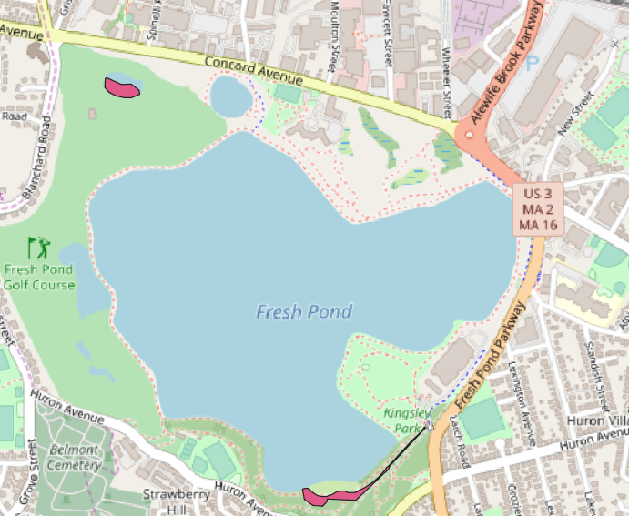

Fig-(1)

This is the result I got after the intersection, the areas colored in pink shows the suitable sites for Farming. Now, I am interested in knowing what type of land it is. For which I need to symbolize each selected site by land use type. For which, I have selected my color classification to Categorized and Classified the areas. The output is shown below.

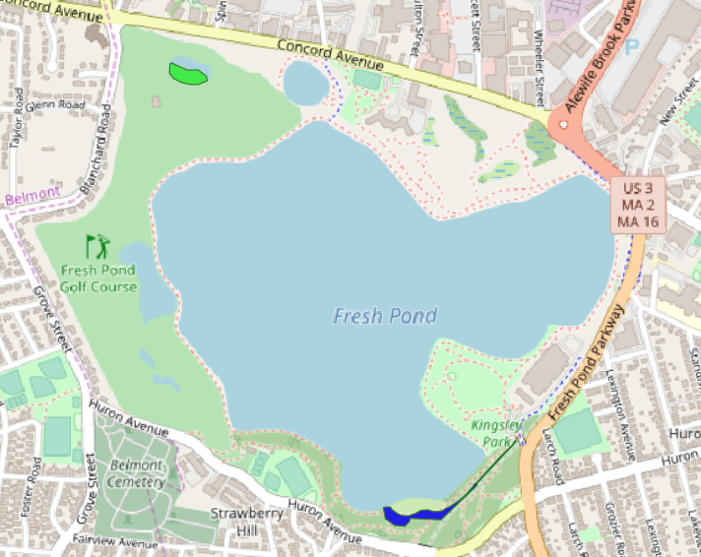

Fig-(2)

Here, we can see the sites in two different colors. What these sites classify is shown in the final output.

**Results:**

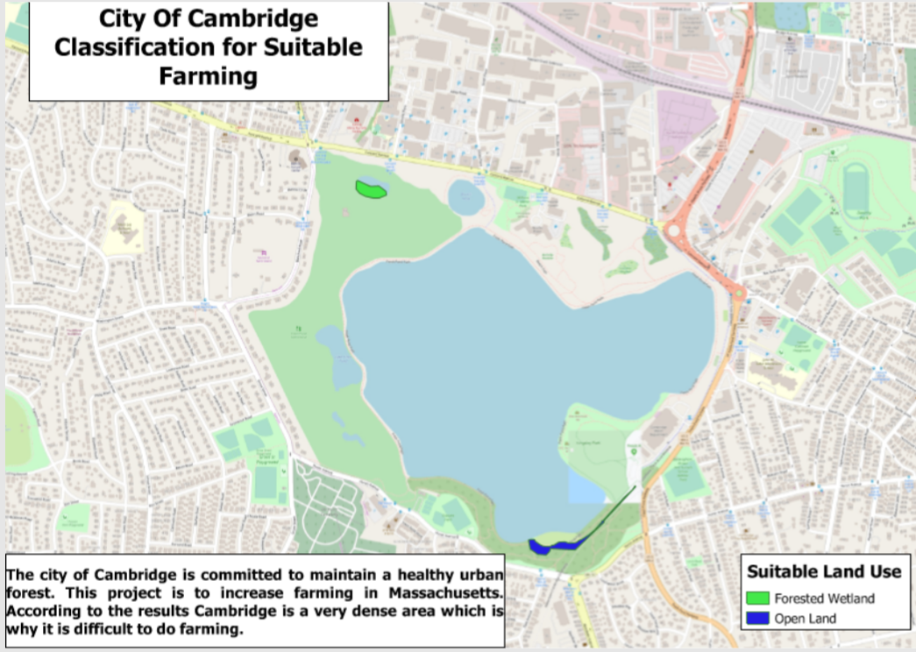

Fig-(3)

The above map is the final output of the problem to identify suitable site for urban farming. In the legend we can see these two sites are Forest Wetland and Open Land. From the results we can say that urban farming is not very feasible in the City of Cambridge because it is a dense suburb of Boston that is highly developed. To get an idea I have another map in the figure below that shows some of the features where we cannot do farming.

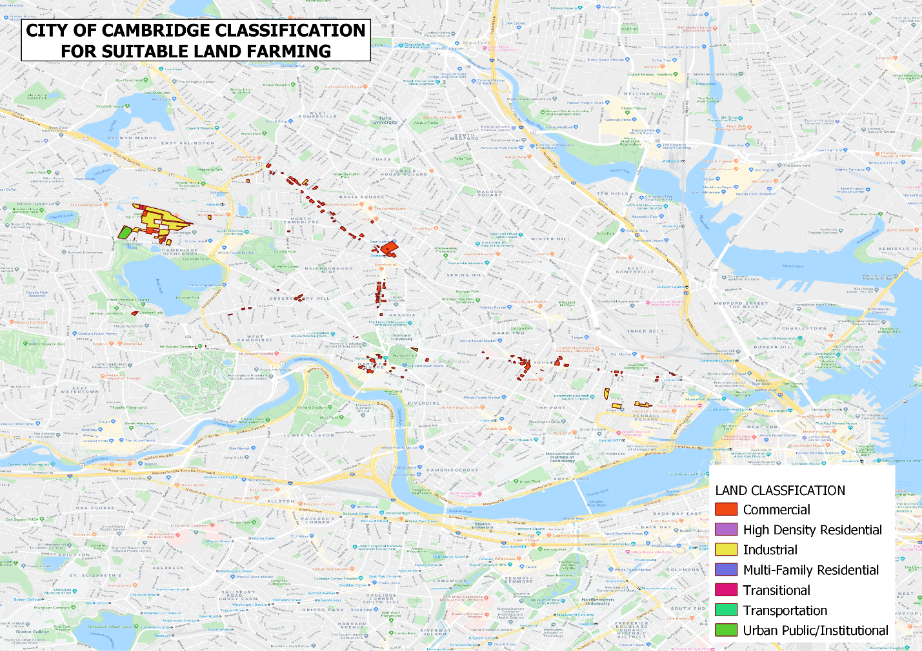

Fig-(4)

The analysis above shows which part is not suitable for farming. So we can see most of the areas of Cambridge is divided into Commercial sites, or it is a high density Residential area, and most of it is industrial.

Thus, as urban farming is not possible, but my suggestion would be to try vertical farming because they occupy much less space than traditional farms, and it is an artificial way of farming. Since Cambridge city is a highly developed city, these types of farming become efficient. Vertical farming can be done in tall, Urban buildings and can be considered an efficient way of farming in urban areas. Apart from, these we can also do a multi-story green house for gardening.

**References:**

Agriculture. (n.d.). Retrieved from <http://www.cambridgene.org/economic_development/business_directory/agriculture>.

Cambridge, C. of. (n.d.). Urban Agriculture Task Force. Retrieved from <https://www.cambridgema.gov/CDD/Projects/Planning/urbanagriculturetaskforce>.

Munoz, K. (2017, June 5). Vertical Farming: Farms of the Future? The Pros & Cons. Retrieved from <https://draxe.com/health/vertical-farming/>.